General Purpose Utilities in Linux

- Display the calender for the month of March 2012

ANSWER:

cal 03 2012
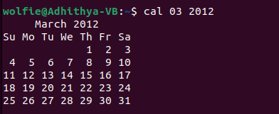

2)List all the files and directories of the directory /usr/lib on the terminal. Now put the same information in a file named results.
Display the contents of the file results now.

ANSWER:

Pwd -> present current working directory.
Cd -> command to change directory if need.
Ls -l -> to list all files in pwd.
Ls -l > results ->to store the required data in results file.
cat results ->to display file results

